ASSIGNMENT 8

Using the contact keeper application that one is shown in video, create function to delete and add new contact in contact keeper application.

Share the screenshot for above output.

# ADD NEW CONTACT

const ContactForm = () => {

  const contactContext = useContext(ContactContext);

  const [contact, setContact] = useState({

    name: '',

    email: '',

    phone: '',

    type: 'personal'

  });

  const { name, email, phone, type } = contact;

  const onChange = e =>

    setContact({ ...contact, [e.target.name]: e.target.value });

  const onSubmit = e => {

    e.preventDefault();

    contactContext.addContact(contact);

    setContact({

      name: '',

      email: '',

      phone: '',

      type: 'personal'

    });

  };

  return (

    <form onSubmit={onSubmit}>

      <h2 className='text-primary'>Add Contact</h2>

      <input

        type='text'

        placeholder='Name'

        name='name'

        value={name}

        onChange={onChange}

      />

      <input

        type='email'

        placeholder='Email'

        name='email'

        value={email}

        onChange={onChange}

      />

      <input

        type='text'

        placeholder='Phone'

        name='phone'

        value={phone}

        onChange={onChange}

      />

      <h5>Contact Type</h5>

      <input

        type='radio'

        name='type'

        value='personal'

        checked={type === 'personal'}

        onChange={onChange}

      />{' '}

      Personal{' '}

      <input

        type='radio'

        name='type'

        value='professional'

        checked={type === 'professional'}

        onChange={onChange}

      />{' '}

      Professional

      <div>

        <input

          type='submit'

          value='Add Contact'

          className='btn btn-primary btn-block'

        />

      </div>

    </form>

  );

};

export default ContactForm;

# OUTPUT

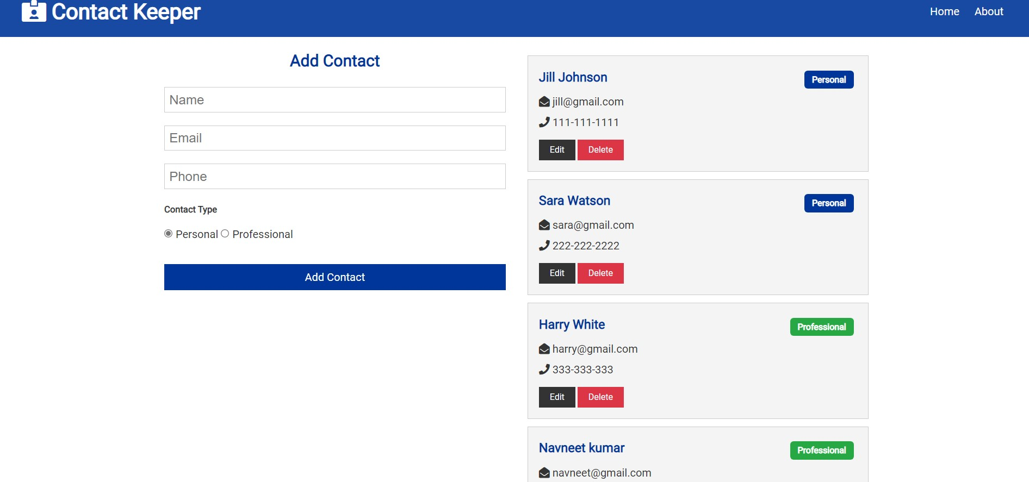

# DELETE CONTACT

import React, { useContext } from 'react';

import PropTypes from 'prop-types';

import ContactContext from '../../context/contact/contactContext';

const ContactItem = ({ contact }) => {

  const contactContext = useContext(ContactContext);

  const { deleteContact } = contactContext;

  const { id, name, email, phone, type } = contact;

  const onDelete = () => {

    deleteContact(id);

  };

  return (

    <div className='card bg-light'>

      <h3 className='text-primary text-left'>

        {name}{' '}

        <span

          style={{ float: 'right' }}

          className={

            'badge ' +

            (type === 'professional' ? 'badge-success' : 'badge-primary')

          }

        >

          {type.charAt(0).toUpperCase() + type.slice(1)}

        </span>

      </h3>

      <ul className='list'>

        {email && (

          <li>

            <i className='fas fa-envelope-open' /> {email}

          </li>

        )}

        {phone && (

          <li>

            <i className='fas fa-phone' /> {phone}

          </li>

        )}

      </ul>

      <p>

        <button className='btn btn-dark btn-sm'>Edit</button>

        <button className='btn btn-danger btn-sm' onClick={onDelete}>

          Delete

        </button>

      </p>

    </div>

  );

};

ContactItem.propTypes = {

  contact: PropTypes.object.isRequired

};

export default ContactItem;

# OUTPUT

